Solving Addition Math Stories
Lesson adapted from Great Minds (UnboundEd), annotated by Student Achievement Partners
GRADE LEVEL One
IN THE STANDARDS: 1.OA.A.1, 1.OA.C.6 (1.OA.C.5)
WHAT WE LIKE ABOUT THIS SET OF LESSONS

Mathematically:
- Highlights multiple ways for students to work towards key grade-level fluency expectations.
- Covers two of the fifteen addition and subtraction problem types students should work with in grade 1 (see additional thoughts below).
- Guides students to move between the concrete and the abstract (MP2).

In the classroom:
- Uses multiple concrete representations, acting, and visual models to make the mathematics explicit.
- Prompts students to share their developing thinking and understanding (Student Debrief and throughout lessons).
- Provides opportunities and suggestions for differentiation.
- Gives formal and informal opportunities for teachers to check for understanding.

For English Language Learners:
This lesson was designed to include specific features that support access for all students and align to best practice for English Language Learner (ELL) instruction. Go here to learn more about the research behind these supports. This lesson aligns to ELL best practices in the following ways:
- Debrief allows for the opportunity to point out metacognitive strategies.
- Tasks are written without unnecessarily complex language.
- Instruction and tasks allow for multimodal representations.
- Lesson provides opportunities for students to practice and refine their use of mathematical language.
- Lesson provides students with support in negotiating written word problems.
- Lesson provides opportunities for whole class, small group, and paired discussion for the purpose of practicing with mathematical concepts and language.
- Embedded sentence frames help students demonstrate their mathematical work and thinking.
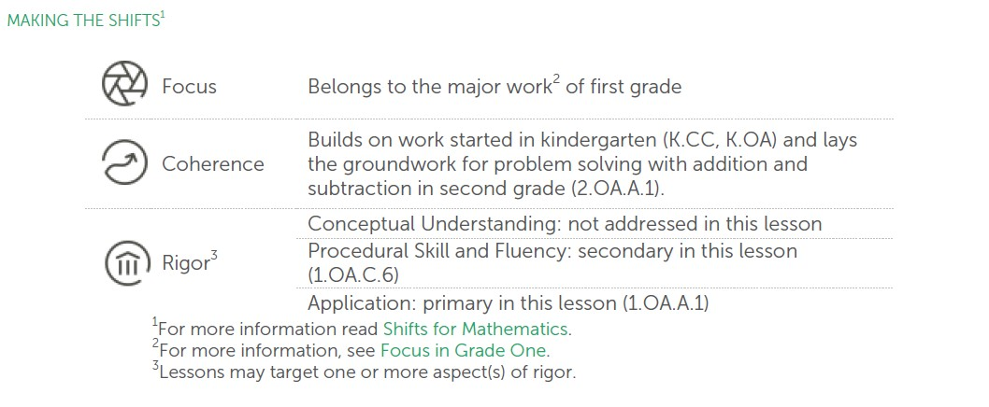

ADDITIONAL THOUGHTS

It’s important to note that this sample lesson is just one of a 39-lesson unit called Sums and Differences to 10. It is not intended for students to meet the full expectations of the grade-level standards addressed in these lessons through only this selected lesson. These sample lessons lay a strong foundation for the work that is to come in the unit. In the subsequent lessons, students explore other types of story problems and get more practice with representing and solving those problems using addition and subtraction.

As indicated in the Table 1 on page 88 of the CCSSM, there are 15 distinct addition and subtraction situations with which students should be able to work. The progression document, K, Counting and Cardinality; K-5, Operations and Algebraic Thinking, gives guidance as to when students should encounter these types of problems and at which grades they should be expected to master working with them.

The structure of these lessons and the unit/curriculum overall have some interesting aspects to highlight. The units make explicit the coherence within the fully developed curriculum. Each topic (a set of lessons) is connected to prior learning and also points to the next lesson that follows in the learning progression. Within individual lessons, there are a number of components that add to their strength including daily fluency practice, variety in questioning techniques, and daily opportunities for students to debrief about their learning.

SUPPORTS FOR ENGLISH LANGUAGE LEARNERS

Prior to this lesson, ensure students have had multiple opportunities to read, write, speak, listen for, and understand the mathematical concepts that are represented by these key vocabulary words:
- equation
- sum
- number sentence
- total

Students should engage with these terms and concepts in the context of mathematical learning, not as a separate vocabulary study. Students should have access to multi-modal representations of these terms and concepts, including: pictures, diagrams, written explanations, gestures, and sharing of non-examples. These representations will encourage precise language, while prioritizing students’ articulation of concepts. These terms and concepts should be reinforced in teacher instruction, classroom discussion, and student work (for example, through engagement in mathematical routines).

Notes on Vocabulary:
- “Number sentence” is a broad term that is used in some math materials to describe both equations and comparison statements.
- “Total” is important for students to know in the context of problem solving but should not be used as a synonym for “sum” since other mathematical operations also result in a “total” number of objects.
- “Put together” is a phrase within college- and career-ready standards that signals to authors/writers of materials a problem type that students are required to solve, but is not vocabulary required for students to know and be able to use.
- “Number bonds” are an important representation for students to recognize and use in this lesson, but should not be treated with the same emphasis on student language use as the key vocabulary words listed above.

Lesson 9
Objective: Solve add to with result unknown and put together with result unknown math stories by drawing, writing equations, and making statements of the solution.

Suggested Lesson Structure
- Fluency Practice (20 minutes)
- Application Problem (5 minutes)
- Concept Development (25 minutes)
- Student Debrief (10 minutes)
Total Time (60 minutes)

Fluency Practice (20 minutes)

- Sparkle: The Say Ten Way 1.NBT.2 (5 minutes)
- 5-Group Flash: Partners to 10 1.OA.6 (5 minutes)
- X-Ray Vision: Partners to 10 1.OA.6 (5 minutes)
- Number Bond Dash: 10 1.OA.6 (5 minutes)

Sparkle: The Say Ten Way (5 minutes)
Note: Providing students with ongoing practice with counting throughout the year builds and maintains their counting skills, which are foundational for later Grade 1 work using the Level 3 strategies of making ten and taking from ten when adding and subtracting.

Ask students to stand in a circle. Introduce the counting pattern, start number, and end number.

T: Today, we will count the Say Ten way from 8 to 13. (Adjust the number range to fit the size of the class, if
needed.)

Before the game, practice the counting sequence as a group and say, “Sparkle!” after the ending number is said aloud.

T: Let’s practice. 8, 9, 10, ten 1, ten 2, ten 3, Sparkle!

Begin the game. Students count around the circle, each student saying one number in the counting sequence. After the ending number is said (ten 3), the next student says, "Sparkle!" and the following player sits. Begin again with the start number, and continue counting in the same direction around the circle until only one player is standing. (See image below.)

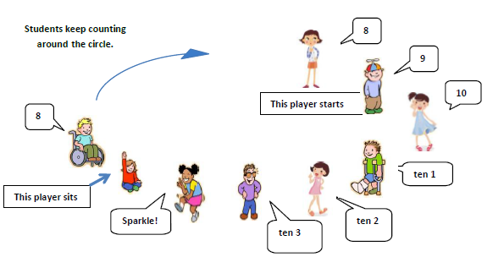

Group Flash: Partners to 10 (5 minutes)
Materials: (T/S) 5-group cards (Lesson 5 Template 1)

Note: This activity addresses the core fluency objective for Grade 1 of adding and subtracting within 10.
Flash 5-group cards for 2–3 seconds, and then instructs students to say the number at the snap. On the second snap, ask students to identify the partner to 10. Remind students they can use their fingers to help. Flash higher numbers first to facilitate finding the partner to 10 so that all students can feel successful.
Next, assign students partners, and instruct them to take turns flashing their 5-group cards with each other.

Ray Vision: Partners to 10 (5 minutes)
Materials: (T) 10 counters, container

Note: This activity addresses the core fluency objective for Grade 1 of adding and subtracting within 10.
    - Tell students you heard a rumor that some of the children in your class are superheroes, and you are wondering if any of them have x-ray vision. Place 10 counters on the floor next to a container.
    - Tell the students to close their eyes.
    - Put 1 of the items into the container
    - Tell students to open their eyes and identify how many counters you put inside it.
    - When a student figures it out, deem her a superhero with x-ray vision!
    - Continue the game, eliciting all partners to 10.

For English Language Learners: Students may be unfamiliar with the terms “rumor” and “x-ray vision.” Consider breaking up the text and clarifying some potentially unfamiliar language. For example:

Tell students you heard a rumor. Tell them that somebody told you that some of the children in your class are superheroes. You are wondering if any of the superheroes have x-ray vision, a superpower that lets them see through objects, like walls.

Number Bond Dash: 10 (5 minutes)
Materials: (T) Stopwatch or timer (S) Number bond dash 10 (Fluency Template), marker to correct work

Note: By using the same system repeatedly, students can focus on the mathematics alone. The activity addresses the core fluency objective for Grade 1 of adding and subtracting within 10.
Distribute the Dash to students, face down. Read directions out loud to students. Instruct students to flip their papers when you say ”Go!” and complete as many number bonds as they can in 90 seconds. Assure them it is okay if they run out of time before they finish. Tell them if they finish, they can practice counting to 20 on the back of their papers, starting with the number 5.

T: (Set the timer for 90 seconds.) On your mark, get set, GO! (Press start.)

T: (When the timer goes off, tell students to put down their pencils and grab a marker to correct their work.)

T: When you get an answer correct, put a check mark on the problem number. If you need to change your answer, just change it with your marker.

T: (Read the number bonds aloud, starting with Problem 1.) When you are finished checking all the problems, write the number you got correct in the star-like shape on top.

Change the counting sequence to meet the needs of students in later lessons. As you choose a counting sequence, consider counting forward or backward by different numbers. When counting forward, it is beneficial to change the starting number.

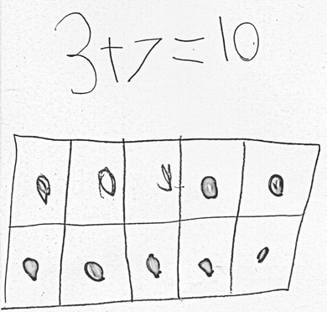
Application Problem (5 minutes)

Kira was making a number bracelet with a total of 10 beads on it. She has put on 3 red beads so far. How many more beads does she need to add to the bracelet? Explain your thinking in a picture and number sentence.
Extension: If Kira wants to use 5 red beads and 5 yellow beads for her bracelet, how many red beads and how many yellow beads does she need to add?
Note: This problem is designed to serve as a bridge from the previous lesson’s focus on decompositions of 10.

For English Language Learners: Act out the application problem by showing an actual bracelet or using a piece of string or yarn to illustrate the act of adding beads.
Highlight what is expected by a picture and number sentence (or equation) from a word wall or previously created visual.

Concept Development (25 minutes)

Materials: (S) Personal white board, number bond and two blank equations (Template)

Have students sit in a large semi-circle facing the front. Use students to act out the math stories. Acting out the story problems allows all students access to the context.

Encourage students to respond in complete sentences through additional
prompting, if needed.
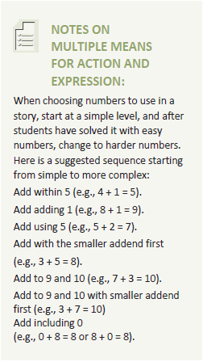
Draw a number bond on the board. Begin the lesson with add to story problems.
T: Good morning, boys and girls. Welcome to Math Stories Theater!
You will be watching some math stories and have a hand at solving them. First, close your eyes. When I tap you on the shoulder, quietly come up to the front.
S: (Close eyes.)
T: (Tap 5 students to come up. Have 1 of the students hide behind the bookcase.)
T: Open your eyes. How many students do you see? S: 4 students.
T: There are 4 students dancing at a party. After a little while, along came their dancing friend, [name of the hiding student]. How many students are dancing at the dance party now?
S: 5 students.
T: This is the total number of students at the party. Let’s show the total in the number bond. (Write 5 in the total portion of the number bond.)
T: How many students were dancing at first? S: 4 students.
T: (Record on the number bond.) How many more students came over to dance?
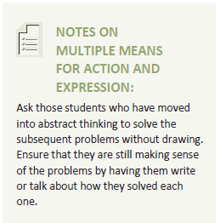
S: 1 more student.
T: (Record on the number bond.) Think about the math story you just watched. Turn and tell your partner the number sentence that tells how many students were dancing in all.
S: (Turn and talk.)
T: Say the number sentence. S: 4 + 1 = 5.
T: (Write on the board below the completed number bond.) What is the total?
S: 5.
T: What does 5 equal? What are the two parts that make 5? S: 4 and 1.

MP.2
T: Say the number sentence starting with 5 equals. (Write number sentence on the board.) S: 5 = 4 + 1.
Analyze the referents for each number, ensuring that students understand what each number represents in the story. Possibly continue with 8 + 1 = 9, but without writing in the number bond on the board.
Choose a group of new actors to act out put together math stories (e.g., 5 students sitting, 2 students standing: 5 + 2 = 7; 3 students facing sideways, 5 students facing forward: 3 + 5 = 8).
T: We will now make math drawings. (Distribute personal white boards.)
T: I will tell you a story and you draw. There are 4 inchworms on a giant leaf. S: (Draw 4 worms on a leaf.)
T: Three more inchworms crawled onto the leaf. S: (Draw 3 more worms.)
T: Does your drawing show the two parts of our story clearly? (Have students share how to make their drawings match the story by drawing two distinct groups.)
T: Write a number sentence to show what happened in your picture and find the total. S: (Write 4 + 3 = 7.)
T: Turn and talk to your partner about what each number tells about the story. S: (Share with their partners.)
T: Write the rest of the number sentences that go with your story.
Possibly continue with the following suggested sequence: 7 + 3 = 10, 3 + 6 = 9, and 0 + 2 = 2.
T: This time, I will only write the number sentence on the board. Your job is to draw a picture with math drawings to match the number sentence. (Write 5 + 2 = 7.)
S: (Draw 5 circles with one color and 2 circles with another color and write 5 + 2 = 7.) Repeat the process for 6 + 4 = 10, 2 + 7 = 9, and 4 + 0 = 4.

Problem Set (10 minutes)
Students should do their personal best to complete the Problem Set within the allotted 10 minutes. For some classes, it may be appropriate to modify the assignment by specifying which problems they work on first. Some problems do not specify a method for solving. Students solve these problems using the RDW approach used for Application Problems.

For English Language Learners: Allow students the opportunity to rephrase with a partner what they see happening in each problem.

Student Debrief (10 minutes)

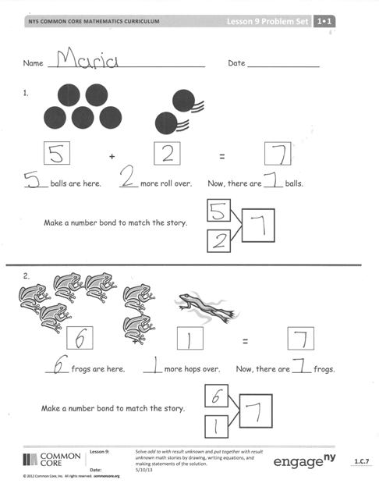Lesson Objective: Solve add to with result unknown and put together with result unknown math stories by drawing, writing equations, and making statements of the solution.
The Student Debrief is intended to invite reflection and active processing of the total lesson experience.
Invite students to review their solutions for the Problem Set. They should check work by comparing answers with a partner before going over answers as a class. Look for misconceptions or misunderstandings that can be addressed in the Debrief.
Guide students in a conversation to debrief the Problem Set and process the lesson. During this conversation, project the problem set for all students to see. If applicable, student work should be shown and discussed. When discussing the stories and how they are similar and different, use a pointer to focus students on the desired visual.
You may choose to use any combination of the questions below to lead the discussion.
- How are the Problem Set stories the same? What did we do to solve them? How are the ball and frog problems different from the flag and flower problems?
- 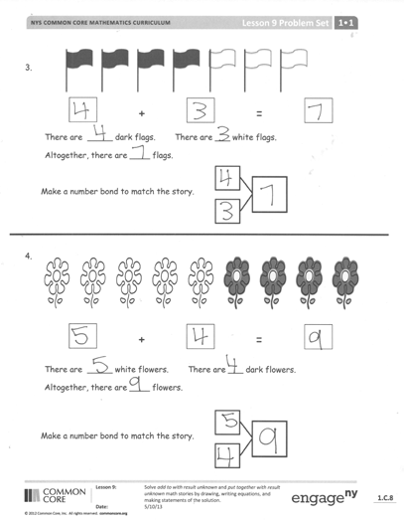Which of our Math Story Theater situations was like the ball and frog problem? Which situations were like the flag and flower problem?
- Use your picture from your personal white board or think of your own story for us to act out for Math Stories Theater!
- How was today’s lesson related to our lesson on ways to make 9? (You may also cite the lessons on ways to make 6, 7, 8, or 10.)

Exit Ticket (3 minutes)
After the Student Debrief, instruct students to complete the Exit Ticket. A review of their work will help you assess the students’ understanding of the concepts that were presented in the lesson today and plan more effectively for future lessons. You may read the questions aloud to the students.

If assigning the homework, tell students that for numbers 1 and 2, they should create a math story based on the picture that leads to an addition problem. They can say it out loud to a friend or family member.

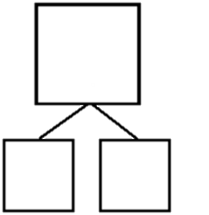
16.
21.
Name
Date
Do as many as you can in 90 seconds. Write the number of bonds you finished here:
2 3. 4.
1.
10
10
.
10
9
10
8
10
9
5.
10
10

6. 7.
8.
10
7
9.
10
8
10.
10
7
10 10
9 8
11.

 | 10 | 12. | 10 | 13. | 10 | 14. | 10 | 15. | 10
6 |  | 7 |  | 6 |  | 5 |  | 4
 | 10 | 17. | 10 | 18. | 10 | 19. | 10 | 20. | 10
 | 6 |  | 4 |  | 3 |  | 4 |  | 3
 | 10 | 22. | 10 | 23. | 10 | 24. | 10 | 25. | 10
0 |  | 1 |  | 2 |  | 4 |  | 2

number bond dash 10

Name Date

1.


+
=

balls more roll over. Now, there are balls.
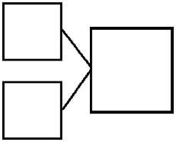

Make a number bond to match the story.

2.
+

=

frogs more hops over. Now, there are frogs.

Make a number bond to match the story.

3.

+
=

There are dark flags. There are white flags.
Altogether, there are flags.

Make a number bond to match the story.



4.

+
=

There are white flowers. There are dark flowers. Altogether, there are flowers.

Make a number bond to match the story.

Name Date Draw a picture and write a number sentence to match the story.


Ben has 3 red . He gets 5 green . How many balls does he have now?

Ben has balls.
+

Name Date

- 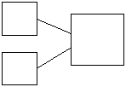Use the picture to tell a math story.
Write a number bond to match your story.


Write a number sentence to tell the story.

+
=

- Use the picture to tell a math story.

Write a number sentence to tell the story.


=
+

There are sharks.

Write a number bond to match your story.
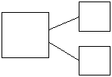

There are students.

- Jim has 4 big dogs and 3 small dogs. How many dogs does Jim have? Draw a picture to match the story.

Jim has dogs.
+
=

- Liv is at the park. She meets 3 girls and 6 boys. How many kids does she meet?

Liv meets kids.
+
=


+
+

number bond and two blank equations

